Group A1 User Manual

Note that we attempted the speaker-related challenges even though we couldn’t get our speaker working. Instead of the speaker, we had the second topmost LED act as our speaker.

Lab Board wirings

|  |  |  |  |
| --- | --- | --- | --- |
| AVR Pins (top and bottom row) | | Input/Output device pins (middle row) | |
| Port Group | Pin | Port Group | Pin |
| PORT F | PF0 | LCD_DATA | D0 |
| PORT F | PF1 | LCD_DATA | D1 |
| PORT F | PF2 | LCD_DATA | D2 |
| PORT F | PF3 | LCD_DATA | D3 |
| PORT F | PF4 | LCD_DATA | D4 |
| PORT F | PF5 | LCD_DATA | D5 |
| PORT F | PF6 | LCD_DATA | D6 |
| PORT F | PF7 | LCD_DATA | D7 |
| MOTOR | Mot | INPUTS | POT |
| PORT K | PK9 | INPUTS | LDR |
| PORT K | PK10 | AUDIO | MiO |
| PORT E | PE5 | LCD_CTRL | BL |
| PORT E | PE3 | AUDIO | Ain |
| PORT D | TDX2 | MOTOR | OpO |
| PORT D | RDX3 | INPUTS | PB1 |
| PORT D | RDX4 | INPUTS | PB0 |
| PORT A | PA2 | LED_BAR | LED0 |
| PORT A | PA3 | MOTOR | LED |
| PORT A | PA4 | LCD_CTRL | BE |
| PORT A | PA5 | LCD_CTRL | RW |
| PORT A | PA6 | LCD_CTRL | E |
| PORT A | PA7 | LCD_CTRL | RS |
| PORT C | PC0 | LED_BAR | LED2 |
| PORT C | PC1 | LED_BAR | LED3 |
| PORT C | PC2 | LED_BAR | LED4 |
| PORT C | PC3 | LED_BAR | LED5 |
| PORT C | PC4 | LED_BAR | LED6 |
| PORT C | PC5 | LED_BAR | LED7 |
| PORT C | PC6 | LED_BAR | LED8 |
| PORT C | PC7 | LED_BAR | LED9 |
| PORT G | PG0 | - | - |
| PORT G | PG1 | AUDIO | ASD |
| PORT G | PG2 | - | - |
| PORT G | PG3 | **LED_BAR** | **LED1** |
| PORT L | PL0 | KEYPAD | C3 |
| PORT L | PL1 | KEYPAD | C2 |
| PORT L | PL2 | KEYPAD | C1 |
| PORT L | PL3 | KEYPAD | C0 |
| PORT L | PL4 | KEYPAD | R3 |
| PORT L | PL5 | KEYPAD | R2 |
| PORT L | PL6 | KEYPAD | R1 |
| PORT L | PL7 | KEYPAD | R0 |
| P11 | +5V | MOTOR | OpE |

# Keypad

The keypad is set up to work as defined in the spec. A picture for reference can be found below:

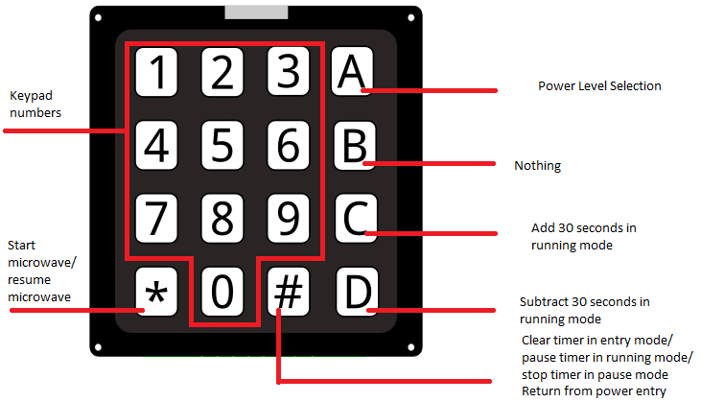

This manual will go into key usage in more detail further below. It should also be noted that

# Push buttons

There are two green push buttons above the keypad. The one on the left (PB1) will open the microwave window and the one on the right (PB0) will close it. The top LED light will light up when the door is open and be off otherwise

# Modes

The microwave is set up to operate in one of four modes:

* Entry – for keying in times and power levels
* Running – for when your food is cooking
* Paused – for when it isn’t (or when you realise you left your spoon in the microwave)
* Finished – for when your food is finished.

## Entry Mode

Entry mode is the default mode that the microwave starts up in. In this mode, cooking time can be entered and the power level of the microwave can be changed. In the bottom left corner you will also be able to see our group name. The cooking time is in the top left hand corner in the format mm:ss with leading zeros. Pressing a key at any time the door is closed will cause the second topmost LED to light up for around 250 ms. As in any mode, you can see the state of the turnstile in the top right hand corner and whether or not the door is open (‘O’) or closed (‘C’) in the bottom right.

### Microwave Power Level

The microwave has three power levels, letting it work at 100%, 50% or 25%. To change the power level of the microwave, make sure you are in Entry Mode and then press the ‘A’ key. The LCD should then display ‘Set Power 1/2/3’. Press 1,2 or 3 to choose a power level of 25%, 50% or 100%. You may also press the ‘#’ button to go back to entry mode. The bottom 8 lights on the LED screen will display the current power level as a percentage of the microwave’s maximum power. If you were to press 2, then the bottom 4 LEDs would light up, signifying that the microwave would be operating at 50% power.

### Time Entry

To enter in the time you want the microwave to operate for, simply start keying in your desired time. The microwave has a maximum limit of 99 minutes and 99 seconds. To clear a time you have entered, press the ‘#’ key. To start the microwave, press the ‘*’ key. Pressing the ‘*’ key when the time is 00:00 will cause the microwave to automatically set a time of 1 minute and begin operation. When the microwave is in operation, it transitions into running mode. Note that if the door is open all keypad inputs are ignored. Holding down a number key will have no effect.

## Running Mode

When in running mode, the turntable will start rotating (the orientation of the turntable can be observed in the top right-hand corner of the LCD screen) and the microwave will cook your food at the desired power level. It is possible to adjust the time while the microwave is running via the C and D buttons, which will add and subtract 30 seconds from the time respectively. If adding time puts the timer over the 99:99 limit, the timer will just be set to 99:99. Trying to subtract 30 seconds off the timer when less than 30 seconds remain will directly end operation and put you into finished mode. The ‘*’ button will also add 1 minute to the microwave’s current cooking time. Finally, opening the door or pressing the ‘#’ key will pause operation and put the microwave into pause mode. The cooking time is in the top left hand corner in the format mm:ss with leading zeros.

## Pause Mode

In this mode, the turntable and the timer will both pause. You cannot exit this mode while the door is open. When it is closed, you can exit it by pressing the ‘*’ key and continuing operation, or by pressing the ‘#’ key and returning to entry mode. The cooking time is in the top left hand corner in the format mm:ss with leading zeros.

## Finished Mode

When finished, the microwave simply displays ‘Done’ on the first line and ‘Remove food’ on the second. It will stay in this mode until either of the push buttons is pressed. When that happens, the microwave goes back to entry mode. The second topmost LED will blink on and off for the next 6 seconds or until Finished mode is exited, whichever happens faster.